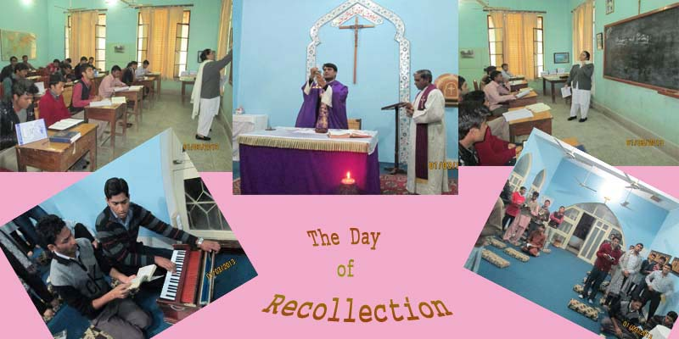
(THE DAY OF RECOLLECTION ) Here the juniorists, together with their formators, are gathered for a day of recollection which, in the Juniorate, is held in the first week of every month. The purpose of this day is to give time to God leaving the usual timetable aside. During this day, we keep silence, reflect upon our life and vocation and strengthen ourselves in faith. It usually begins with the night prayers and ends with lunch the next day. This time Sr. Shalomi, a Dominican nun led us in reflection and prayer.

