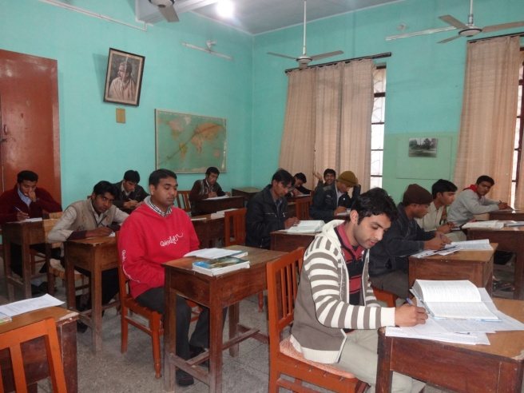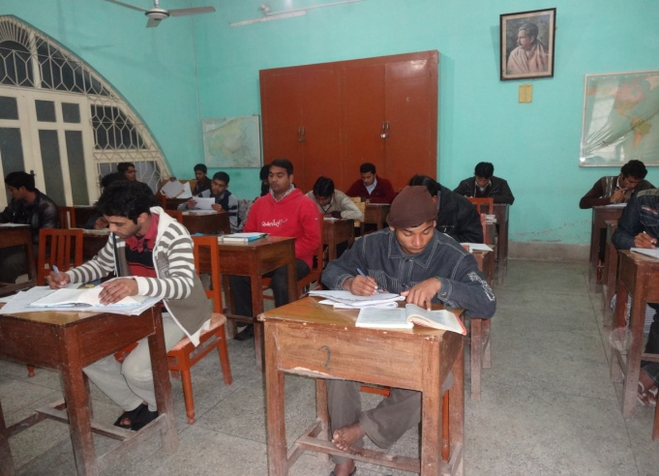
(Entrance Exam) The students of the third year prepare themselves for entrance exam. It is an English language competency test conducted by St. Francis Xavior's Seminary, Lahore. Passing this exam is a prerequisite to be promoted to the Oblate Philosophate in Lahore.

